**Backup restore tests - customer request:**

If we received any restore requests, we have check on the below points.

* What kind of restore they required, whether it is file level restore or disk restore or entire VM restore.
  + Check whether AMI is available or not. If not then need to check whether instance is getting backed up or not.

If Backup is available, Follow below steps,

1. Login to AWS Portal
2. Go to EC2 check for the Server and stop it.

Check for the root volume NAME(Device name or the volume name of root volume would be either /xvda or /sda1)

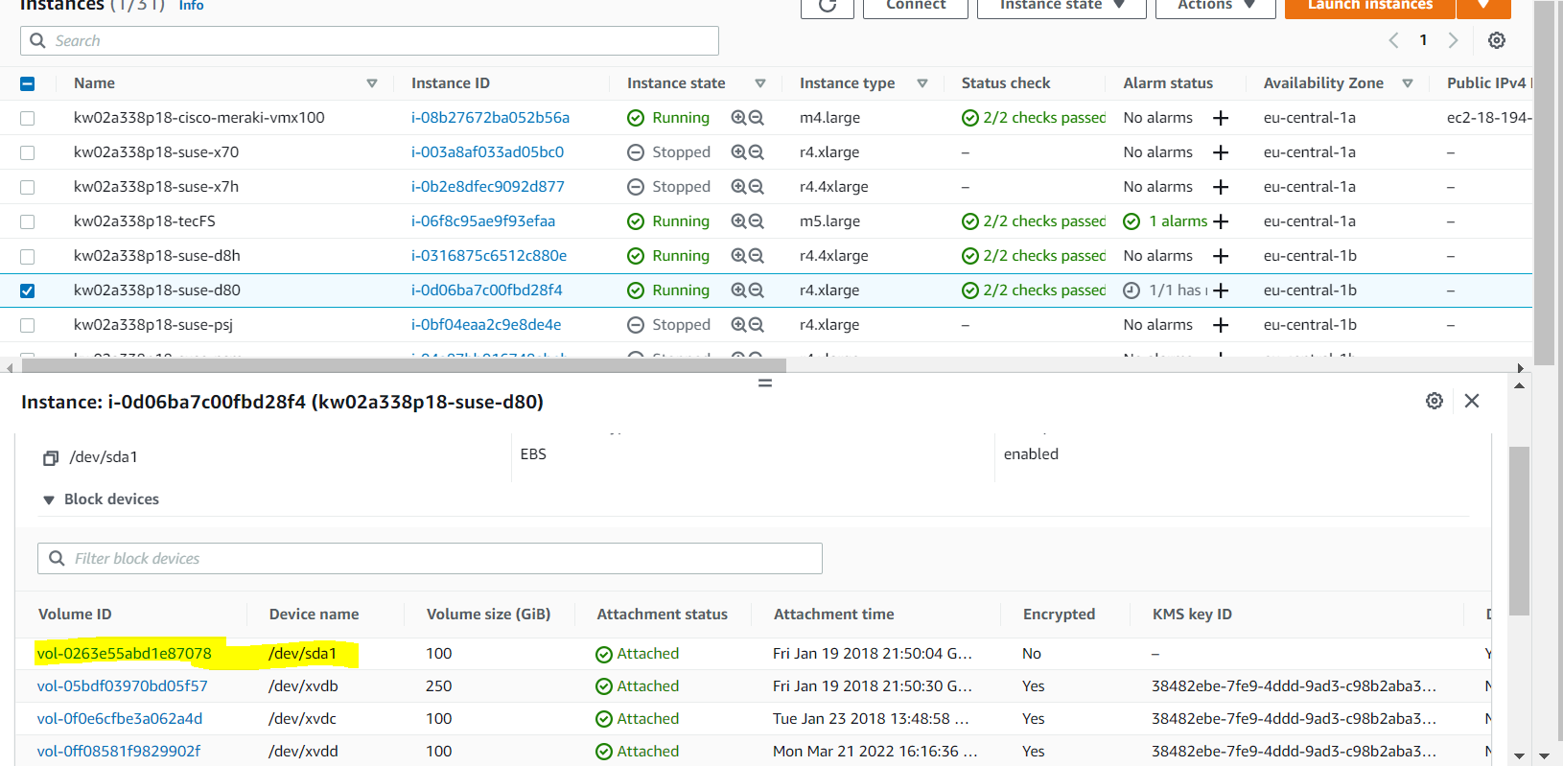

1. Detach that root volume or the mentioned volume from server.
2. Go to snapshot under ec2,

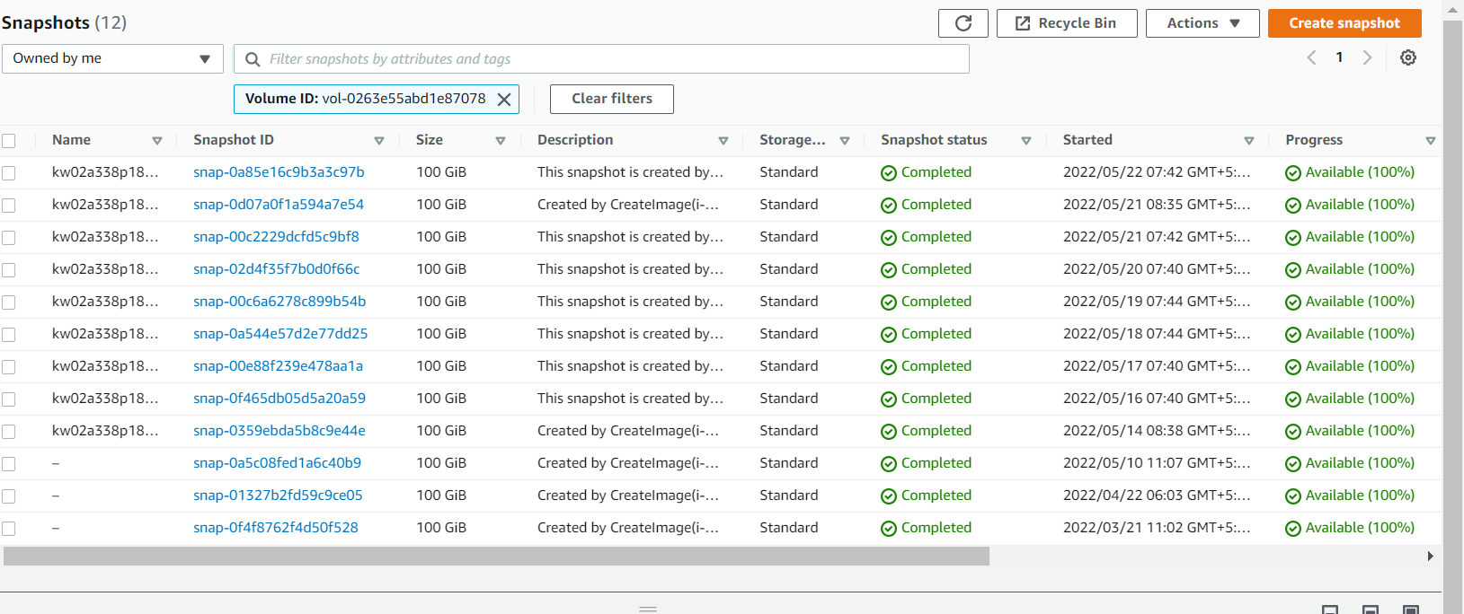

1. Check for the recent backup. And Create volume of that snapshot.

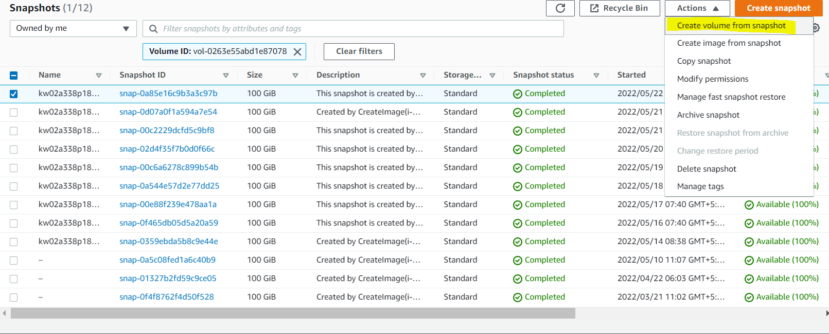

1. While creating volume from snapshot cross verify name and region attributes.
2. Then attach that volume to the server and start the server and confirm status checks.